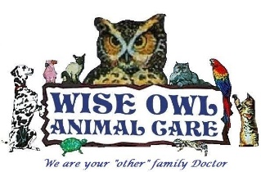
Preventative Care for Your Pet
What is the importance of preventing parasites in my pet?
All pets should be on a parasitic preventative program because Guam is infested with internal and external parasites. Mosquitos are very abundant and transmit heartworm disease to pets on Guam. The soil is contaminated by Hookworms, Roundworms and Whipworms because fecal matter is left on the ground. Fleas and ticks thrive in warm, humid, dark areas (leaf litter, soil, debris etc.) where 95% of them are in the environment and 5% of them live on your pet.

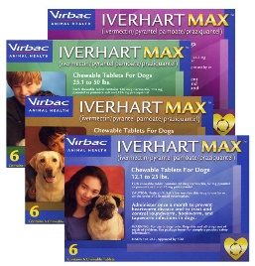
What types of preventative programs can I put my pet on?
Here is a list of preventative programs we recommend your pet be on in Guam.
- Once a Month Programs
  - Iverheart Max
Monthly preventative ill kill the larva stage of the heartworm &
controls hookworms, roundworms and tapeworms.
  - Ivermectin/Grenadine (red medicine)
Monthly preventative kills heartworms, roundworms & hookworms.
This red medicine is a cherry flavored liquid that is given by mouth.
  - Sentinel
Monthly prevention kills heartworms, roundworms, hookworms and whipworms.
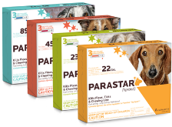
It breaks the life cycle of fleas by eliminating the eggs. This tablet is beef flavored and dogs love it.
  - Parastar
Monthly prevention kills Fleas, ticks, chewing lice & mites that cause Sarcoptic mange.
This is a liquid that is applied between the shoulder blades of your pet.
- Twice a Week Program
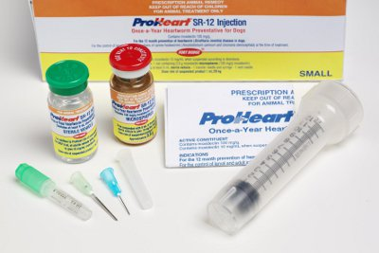
  - Ivermectin/Grenadine (Red Machine) - when given twice a week, it kills a broad spectrum of parasites such as heartworms, roundworms, and controls fleas, ticks, lice and mites.
- Once a year program
  - Proheart Injection - Proheart is given as an injection.
It protects your pet against Heartworms, Roundworms & Hookworms for one year
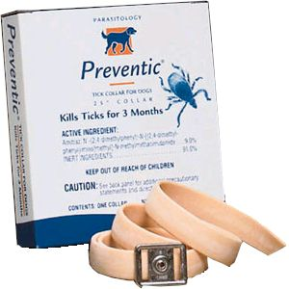
- 3-Month Program
  - Preventic Collar - Collar provides protection against fleas & ticks.
This can be used with other preventative products.
- 8-Month Program
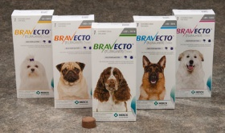
  - Seresto Collar - Collar provides protection against Fleas & Ticks.
This can be used with other preventative products.
- 12-Week Program
  - Bravecto - Pill that kills adult fleas and ticks.
This can be used with other preventative products.

Prevention Program | Products | Protects Against X = Best benefit |  |  |  |  |  |  |  |  | Pricing
 |  | Heart-worms | Round-worms | Hook-worms | Whip-worms | Tape-worms | Fleas | Ticks | Lice | Mites
Once  a  Month | Iverheart Max | X | X | X |  | X |  |  |  |  | $$$
 | Sentinel | X | X | X | X |  | Eggs Only |  |  |  | $$$$
 | Ivo/Gren Red Medicine | X | X | X |  |  |  |  |  |  | $
 | Parastar |  |  |  |  |  | X | X | X | Sarcoptes | $$$
Once  a Year | Proheart  Injection | X | X | X |  |  |  |  |  |  | $$$
Twice  a  Week | Ivo/Gren  Red Medicine | X | X | X |  |  | X | X | X | X | $
3-Month Program | Preventic  Collar |  |  |  |  |  |  | X |  |  | $$
8-Month  Program | Seresto Collar |  |  |  |  |  | X | X |  |  | $$$$

